January 23, 2017

Dear Prospective Sponsor:

In May 2017, the Alma Highland Festival and Games will be celebrating 50 years of all things highland and we wish to invite you to be a part of the festivities!

You have an incredible opportunity to support this event that brings together communities across the globe by giving financially. Because the Alma Highland Festival and Games is run solely by volunteers and is backed by sponsors and donations, we are seeking area businesses and people alike who believe in this festival and what it does for our community and who wish to support the Festival’s longevity.

Each level of giving is fully outlined in the attached sponsorship form and provides you the chance to choose which level of sponsorship you are interested in being a part of that supports the Festival as a whole. Knowing that the Festival takes approximately $200,000 annually, to be fully funded, we are reaching out to you and asking you to seriously consider your commitment in seeing the Alma Highland Festival’s success for its 50th year and years to come.

Commitments are asked to be solidified by April 14, 2017. Please fill out the attached sponsorship form and return to:
Alma Highland Festival, P.O. Box 516, Alma, Michigan 48801

We look forward to continuing our Scottish celebrations in Scotland, USA, and with your support we know it can happen!

Thank you again for considering.

Best regards,

Paula Moeggenborg
Alma Highland Festival and Games
highland@almahighlandfestival.com
AHF Office :989-463-8979

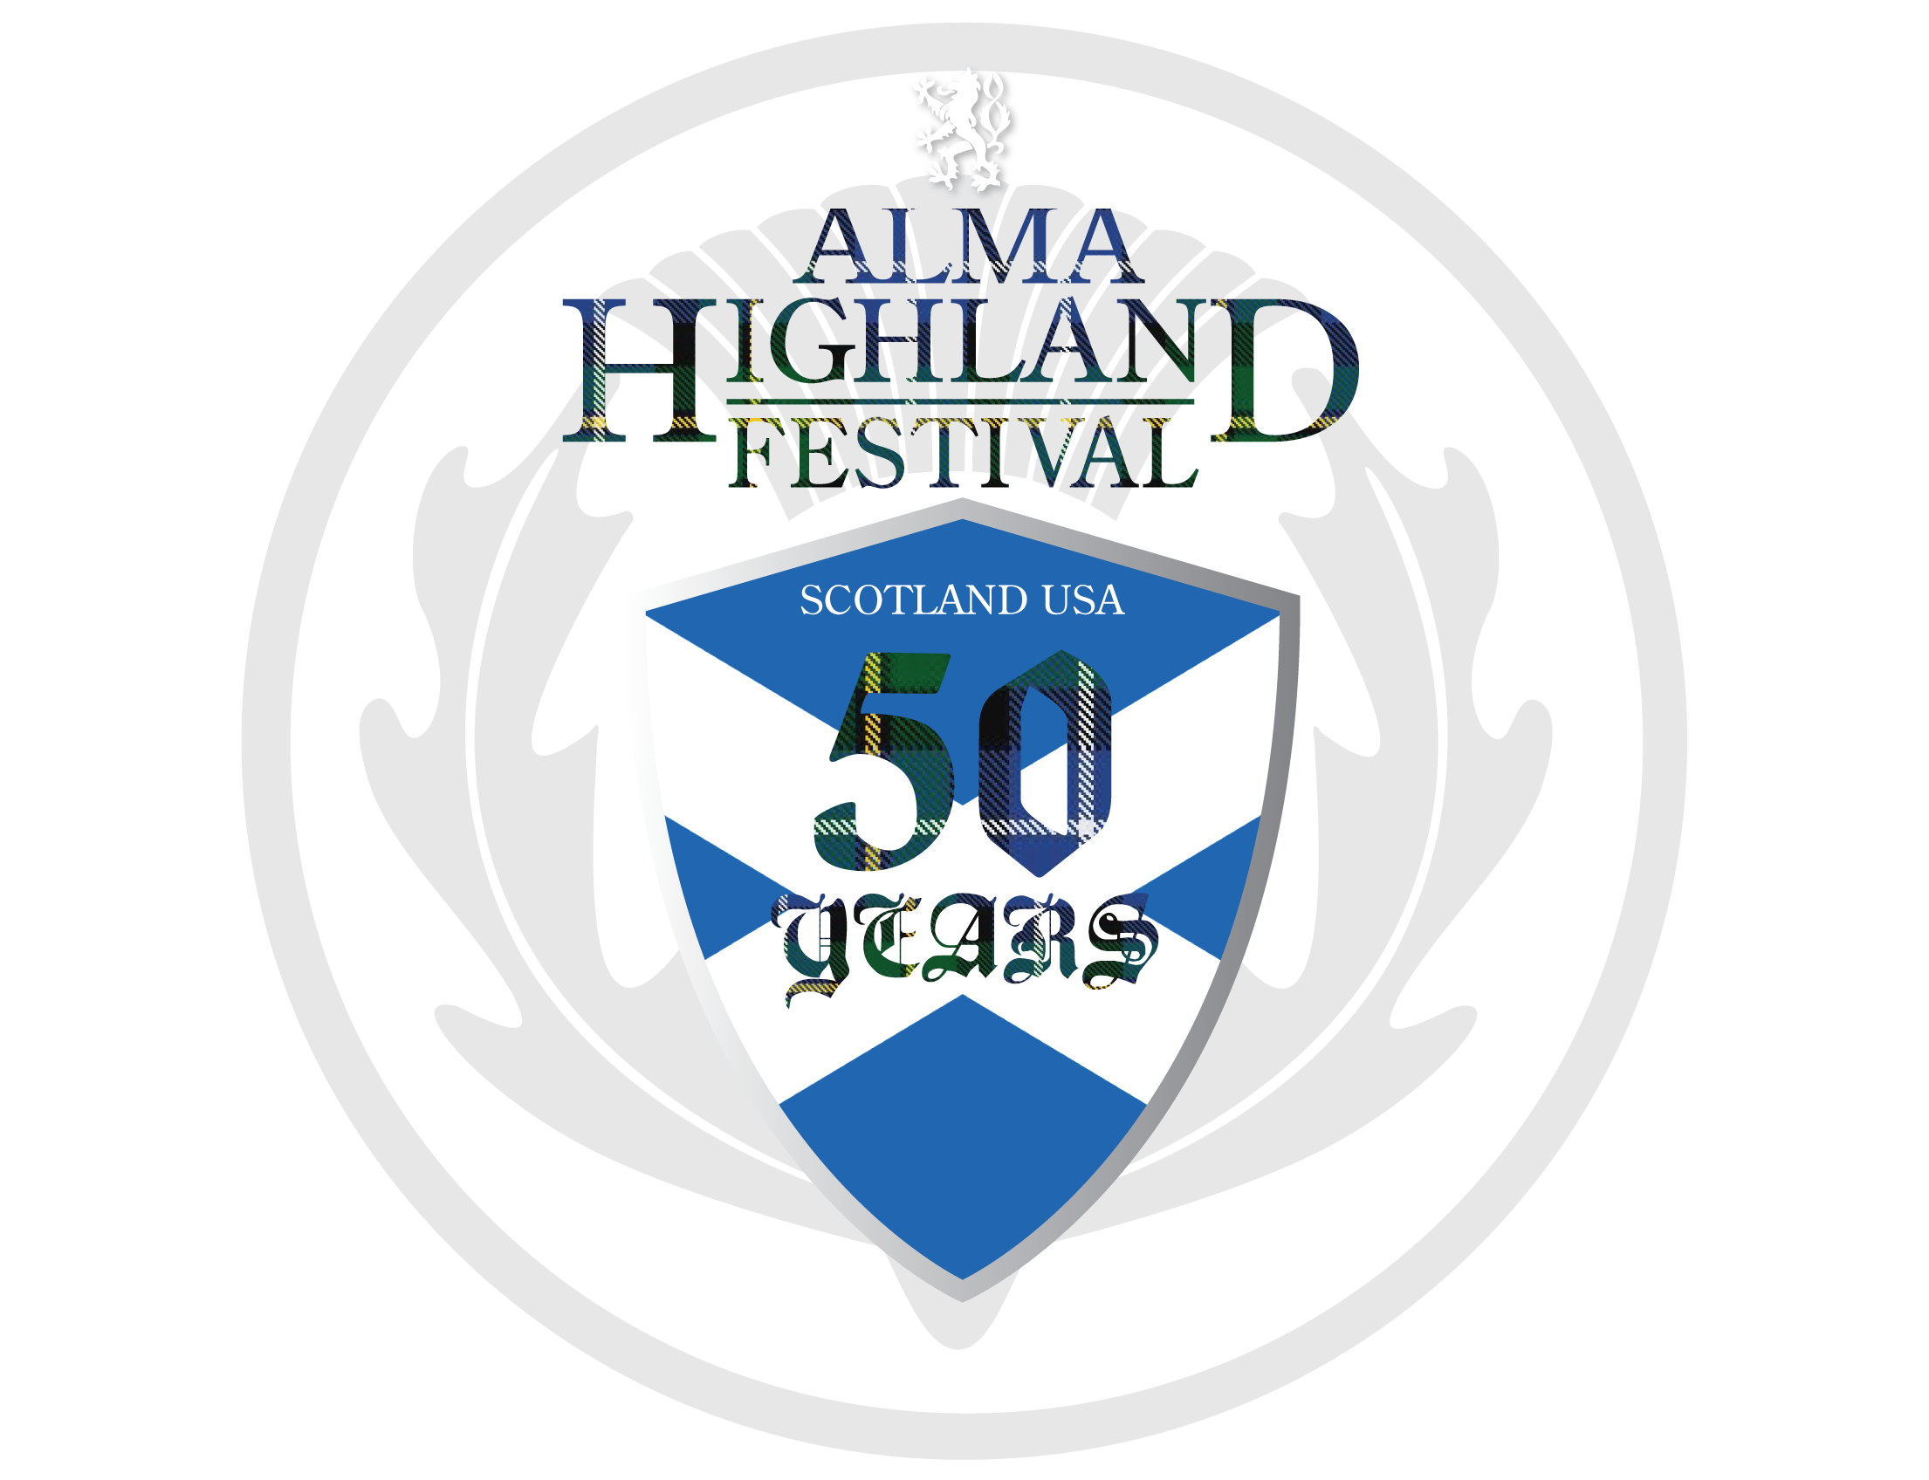

2017 Alma Highland Festival and Games
SPONSORSHIP FORM
Please return this form and check made out to
“Alma Highland Festival and Games” to:
Alma Highland Festival and Games
P.O. Box 516
Alma, Michigan 48801
Company/Organization: _______________________________________________________________________________
Contact Name: ___________________________________________________________________________________________
Address: ___________________________________City: ________________________ State: _______ Zip: ____________
E-mail address: ________________________________________ Phone number: (______)_______- _____________
Website for us to get logo (if applicable): _________________________________________________________
Donation Information: (Please check appropriate box)
☐ Great Scot Level– $2500 +
- Four (4) VIP passes to Entertainment Tent, seats on field for Opening and Closing ceremonies, Festival t-shirts, and Festival weekend wristbands; full-page ad in Festival program; name on Road Race t-shirt; and name promoted at all events during Festival weekend
☐ True Scot Level– $1500 - $2499
Full-page ad in Festival program; name on Road Race t-shirt; two (2) Festival weekend wristbands; and name promoted at all events during Festival weekend
☐ Thistle Level – $1000 - $1499
Half-page ad in Festival program; two (2) Festival weekend wristbands; and name promoted at all events during Festival weekend
☐ Rampant Lion Level – $500 - $999
1/4-page ad in Festival program and name promoted at Entertainment Tent and Road Run competition during Festival weekend
☐ Tartan Level – $250 - $499
1/8-page ad in Festival program
☐ Highlander Level – Other Amount: $_________
Name listed on Sponsor List in Festival program and local newspapers

